

**LEFT(OUTER) JOIN:**

|  |  |  |  |  |  |
| --- | --- | --- | --- | --- | --- |
| P | Q | R | A | B | C |
| 10 | a | 5 | 10 | b | 6 |
| 10 | a | 5 | 10 | b | 5 |
| 25 | a | 6 | 25 | c | 3 |
| 15 | b | 8 | - | - | - |

Left join returns all records from the left table and matched records from the right table.

The result from the right table is NULL if there is no match to the left table record.

**SYNTAX**:

select column_name from table1 **left join** table2 on table1.column_name = table2.column_name;

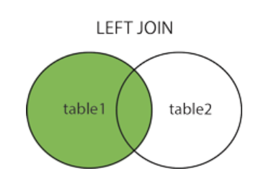

**QUERY:**

1). select employees.first_name, employees.last_name, department.manager_id from employees left join departments on employees.manager_id = department.manager_id;

